**7**

Arithmetic, conditionals

1. Your task is to write a simple calculator script using bash.

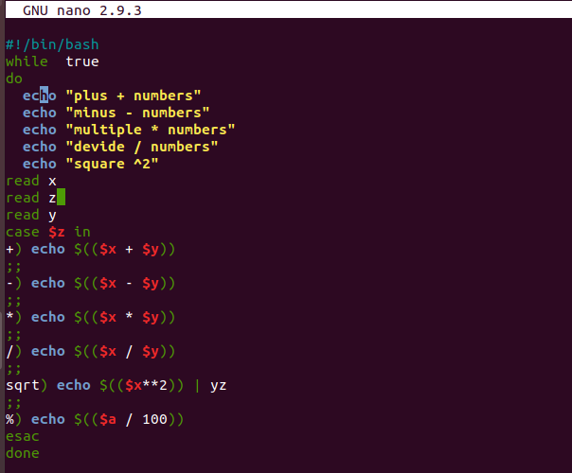

1. Your task is to write a point -> grade calculator using bash. Program should ask for student’s name, ID, and point (like 75, 90, 100 etc.) and convert it to grades (B-, A-, A etc).

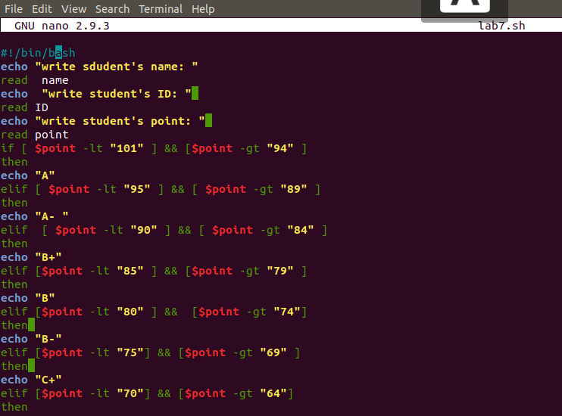

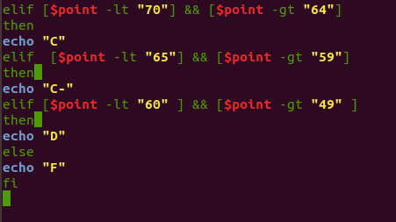

1. Your task is to create a GPA calculator. Script should ask for 5 classes with following format:

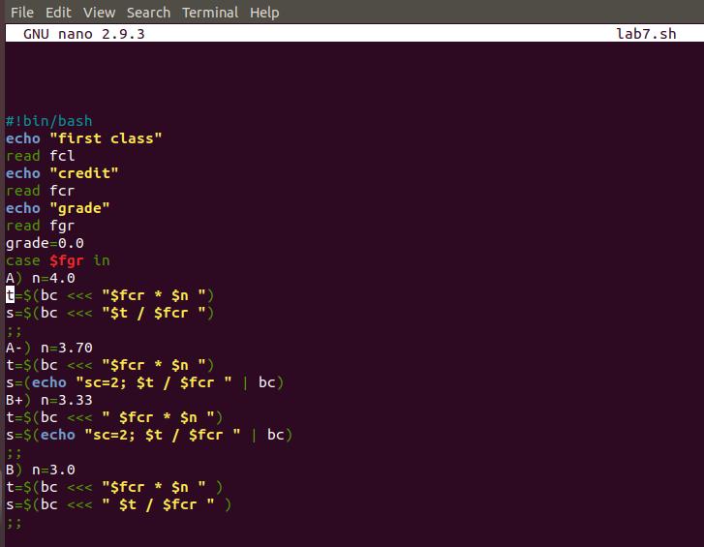



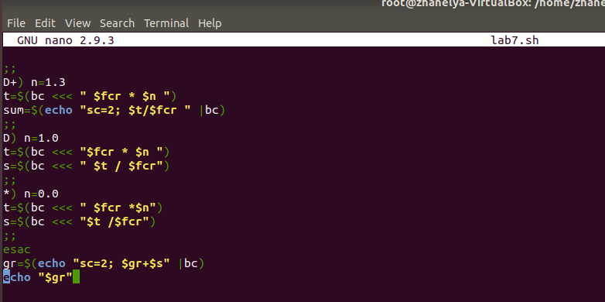

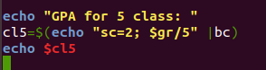

4. Create script that:

- prints out current directory

- asks for a filename

- if file doesn’t exist, show error message

- deletes file if file is writable and executable

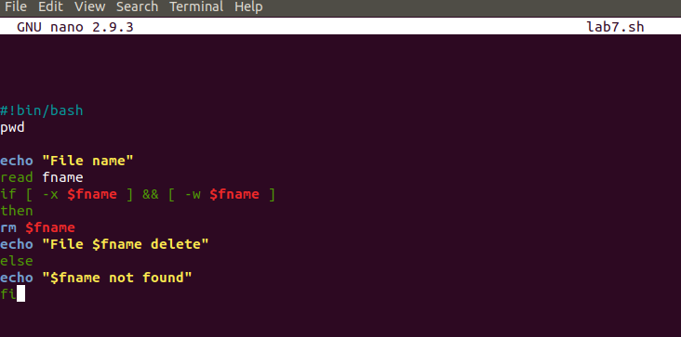

5. Create script that:

- asks for a username

- asks for choice: block or unblock user

- blocks or unblocks user

